World Communication Forum in Davos: Expanding the horizon of Communications

‘World Communication Forum has turned into a serious player in the global field of public and business communications!’, ‘The best global meeting point for communications, cultures and people that I know’, ‘Despite the diverse nationalities, skills and backgrounds – there was a common willingness to exchange knowledge and ideas and a shared passion for improving the communications profession.’
These are just some of the great impressions of various participants who joined the 5th annual edition of World Communication Forum in Davos. Full summary of the event you can find here:http://www.forumdavos.com/events/2014.

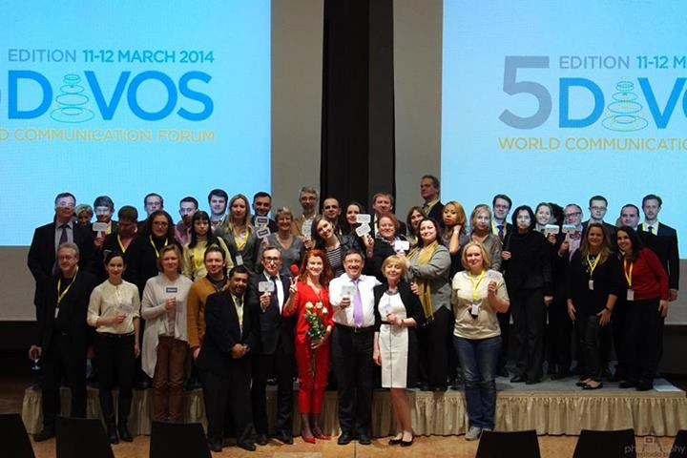
The closing of the fifth annual edition of World Communication Forum in Davos

Hundreds of participants attended the two-day event held on March 11-12. Since its first edition in 2010 the forum has been taking place in Davos Congress Centre, Davos, Switzerland. This year’s speaker lineup united professionals from 28 countries including USA, Malaysia, Mexico, Italy, Belgium, France, UK, India, Russia, Brazil, Bulgaria, Croatia, Germany, Hungary, Latvia, Netherlands, Poland, Portugal, Serbia, Slovenia, Switzerland, Turkey.

One of the key topics in the agenda raised the question about the future of Public Relations: a lively debate sparked around several past-years’ predictions that the essence of the industry might change for good under the influence of Digital Communications and Social Media. At the end of the day, the conclusion was: PR is not dead. It is just improving for the better.
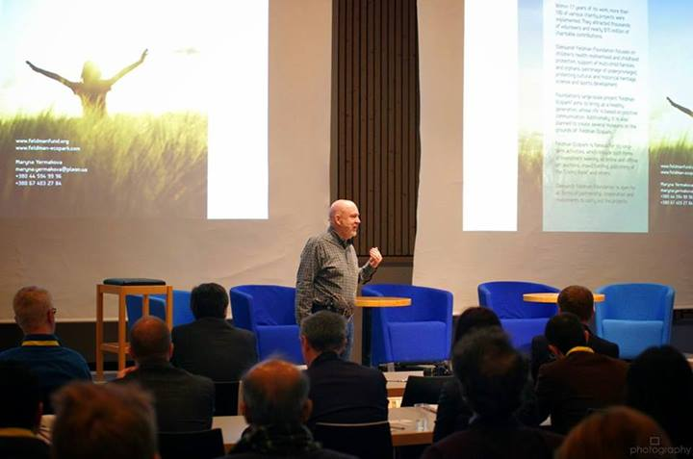
Paul Holmes during the first panel discussion at WCFDavos 2014.

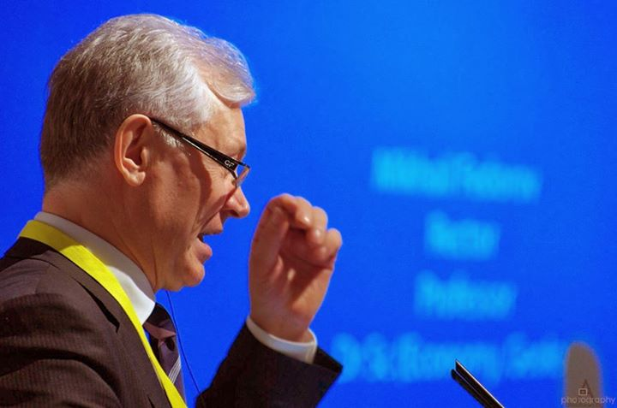
Prof. Dr. Mikhail Fedorov, Rector of the Ural State University of Economics at WCFDavos 2014

More than 780 people followed the event on Twitter in order to share opinions, ideas and take part in the discussions using the official #WCFDavos hashtag, whilst over 180 announcements and publications from different media across the globe started circulating information about World Communication Forum five months before the event, the latest ones appearing only in the past couple of days.

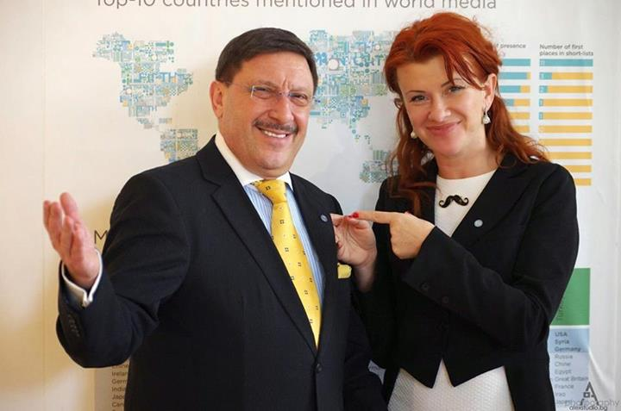
Maxim Behar and Yanina Dubeykovskaya, Co-Chairs of WCFDavos Committee

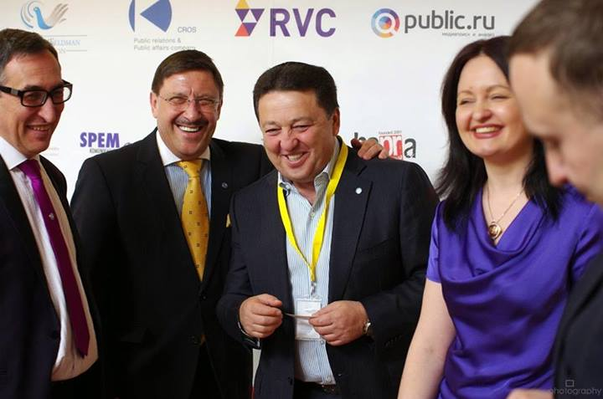
Alexander Anisimov, Maxim Behar, Oleksandr Feldman, Iryna Zlotarevych at WCFDavos 2014

For its fifth edition, WCFDavos was supported by 5 major companies operating in the field of communications, education and healthcare: the Russian Venture Company, the International Charitable Fund - Oleksandr Feldman’s Foundation, CROS Public Relations & Public Affairs, Ural State University of Economics (USUE), and Gedeon Richter Plc.
The international WCFDavos team worked in collaboration with 35 partners amongst which large professional associations, universities and agencies across 5 continents.
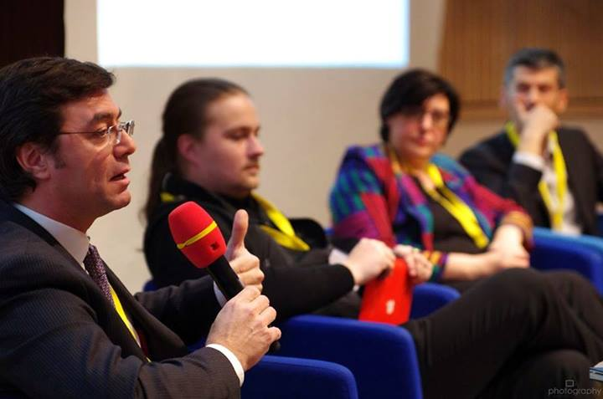
Dicran Babayantz, Lars Hilse, Virginie Coulloudon and Eric Maillard: 'Do you e-xist?' panel
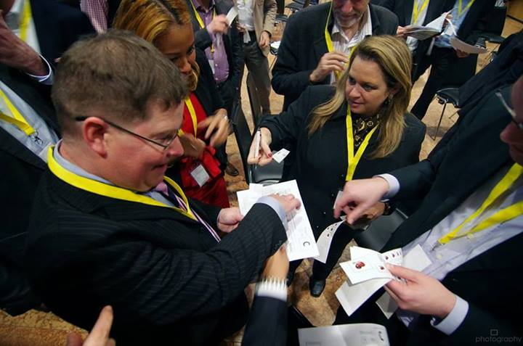
The "3 Whales" Game, in the photo: Nurul Ashiqin Shamsuri, Stuart Bruce and Adriana Vieira

The WCFDavos family continues to expand, welcoming new members with each next edition and uniting top expertise of the communications community worldwide in order to develop and improve the future of the industry.
_________________________________
WCFDavos is held annually at Davos Congress Centre in Switzerland. Initiated in 2010 by an international committee, it aims to address pertinent issues in public relations and corporate communications via a platform for sharing best knowledge and ideas. Forum’2014 summoned top experts from Hill+Knowlton, Oleksandr Feldman’s Foundation, Ural State University of Economics (USUE), Gedeon Richter Plc., Ogylvy, Siemens AG, World Wide Fund for Nature (WWF), CERN, CROS Public Relations & Public Affairs, International Communications Consultancy Organization (ICCO), Russian Venture Company, Mexican Communication & Marketing Industry Confederation, and many more. For further details, please visit: http://www.forumdavos.com/

