Scott Fahlman: Once your creation is out there, you can't control how it changes and how it is used
"The man who created the smiley: I know how Dr. Frankenstein felt"
Intreview by Erika Fuks (March, 2014), for Delfi Versals: http://bit.ly/1e3CmHG

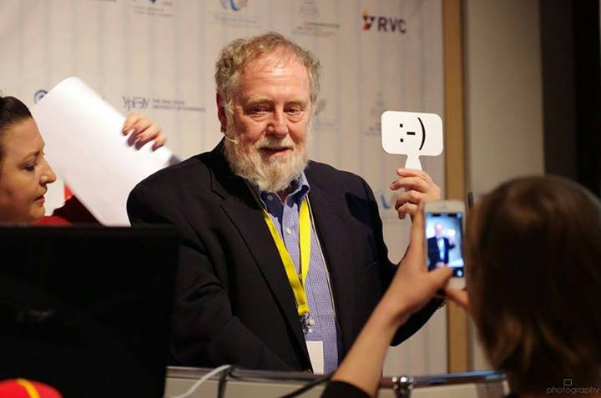
1. You are known for your work in many fields, but would you call the creation of the smiley the most known of your ideas?
Yes. It's very strange, because I have been doing cutting-edge research in artificial intelligence for 45 years, but I am best-known for a silly comment on an online bulletin board in 1982 that took me ten minutes to compose.
2. If not, what other idea could you name as best known?
I have made some significant contributions to representing and using common-sense knowledge in computer software, and in speeding up learning in artificial neural nets. My AI work has been cited almost 8000 times by other scholars, which is a big number in our field.
3. What extra value has the smiley brought into your life?
Well, it's fun to be famous for something, even if not for my most important work. I get to talk to journalists from around the world, and sometimes I get invited to nice places like Davos to talk about this.
4. Why are emotions in online communication important?
I'm not sure I would claim they are important. I think they serve a purpose: In informal online communication, we need an easy way to say "I'm only joking" or "I'm really angry." The :-) and :-( symbols are a quick and easy way to say that, in a sort of universal language.
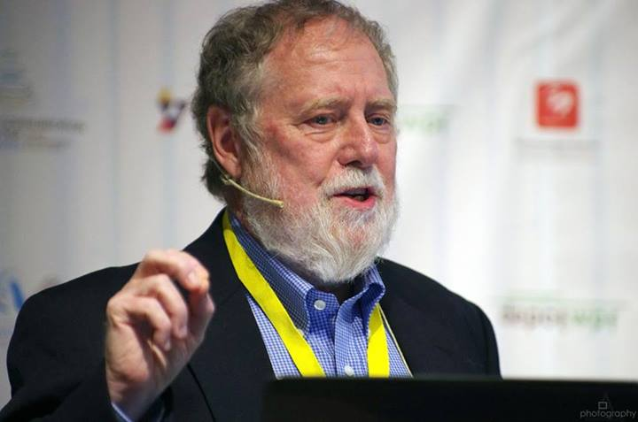
5. What general changes have you noticed in communication?
Do you mean to ask how has communication changed since 1982? That's a very big question. Everything has changed, almost beyond recognition. International phone calls used to be a lot of effort and a big expense; now I have video Skype in my pocket. There are social media sites with over a billion users. Print newspapers and magazines and physical books are nearing extinction, but we can access all of that in color and high resolution on our pocket devices. So it's easier to ask what hasn't changed.
6. What changes are yet to come in the communications field?
- We’ll be able to get real-time translation of phone calls from any widely-used language to any other, and our phone/camera will translate signs and menus. So language barriers just go away.
- We will have intelligent reference librarians with common-sense knowledge, so that we can ask questions and get real answers -- not a page full of Google hits that may contain some of the same words as our query. (I'm working on some parts of this.)
- If the outdated copyright laws can be fixed, we should have instant access to any book or article published anywhere, and at any time in history, translated into the language of your choice -- and an easy mechanism so that the reader can be charged a small amount that will go to the author.
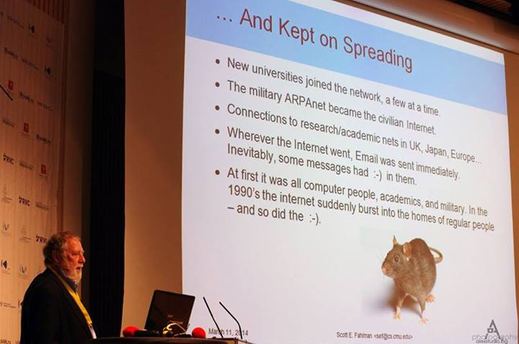
7. What will be the key message of your speech in Davos' „World Communication Forum“?
I'll just be talking about how the :-) and :-( emoticons were invented, how they have changed and spread all around the world, and a few ideas about why they have become such a popular and long-lasting "brand", even without any commercial backing. Not sure if there's a big message in the talk, but here are a few ideas:
- Symbols are more likely to spread and survive if they are intuitive and immediately recognizable. A bit of whimsy and identification with some "in group" can also help. And if they tap into some universal emotion, that's even better.
- You never know what small little comment or idea is going to take off. So save a copy.
- Once your creation is out there, you can't control how it changes and how it is used. Sometimes I know how Dr. Frankenstein felt...

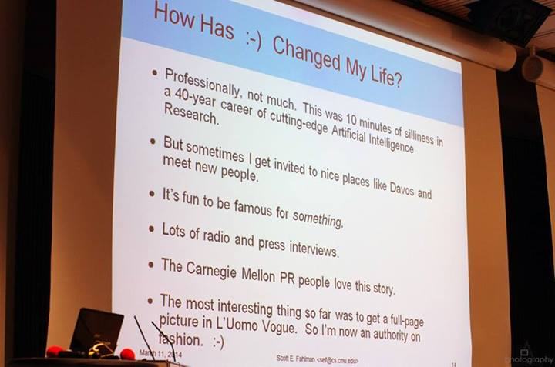
Slide from the presentation: :-) The (Unintentional) Birth and Evolution of a Successful International “Brand”.

Source: Original interview - available at: http://bit.ly/1e3CmHG

