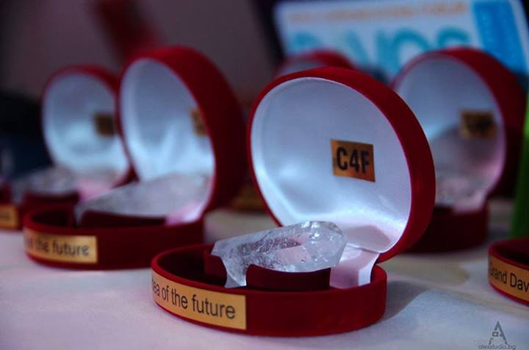
C4F Davos Award 2014 Focused on the Future
Six great awards were given at the Gala Dinner of the World Communications Forum in Davos, when the most outstanding communications experts and all Forum participants gathered for the C4F (Communications for Future) Davos Awards ceremony.
C4F Davos Awards are rendered to communications professionals for their ability to foresee the next steps in the development of the industry, as well as their contribution to public or business communications. Each year the final voting procedure is executed by the members of the International WCFDavos Committee.
The awards are presented in six categories: "Titan of the Future", "Image of the Future", "Media of the Future", "Relations of the Future", "Idea of the Future" and the "Grand Davos Award".
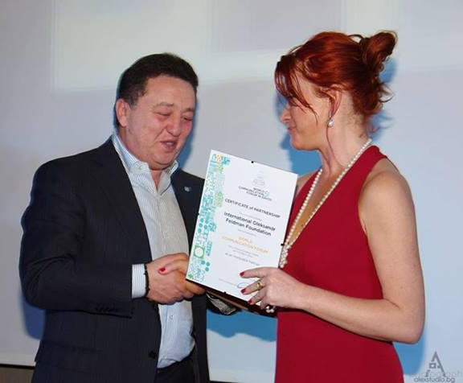
This year, a new nomination - "Tolerance for the sake of the Future" - was announced. The nomination has been created and is due to be supported by the International Oleksandr Feldman Foundation. It was presented by Mr. Feldman himself. The prize for promoting tolerance in communications and for significant contribution to the future of socially responsible communications will be awarded each year during the World Communication Forum in Davos. Entry to the award is open to directors of NGOs, as well as CSR managers of companies practicing the philosophy of tolerance through communications, social projects, and participation in forums or exhibitions.
The International Oleksandr Feldman Foundation is an official partner of the 5th World Communication Forum in Davos.
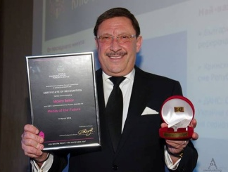
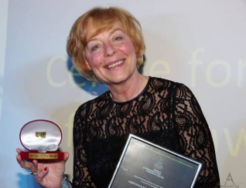
"Image of the Future" award was rendered to Maria Schicht, the Marketing Director of Warsaw Municipality - for the excellent reputation-management and image-promotion of Warsaw.
“Media of the future” prize was delivered to the world-known PR expert from Bulgaria - Maxim Behar, for his project Novinite.com, developed in 3 languages - Bulgarian, Russian, and English.
“Idea of the future” went to Isaac Mao, co-Founder and Director of the Social Brain Foundation and establisher of CNBlog.org - for actively developing of the concept and ideas of the Sharism philosophy.
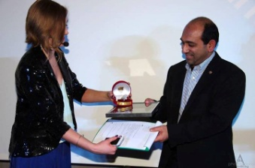
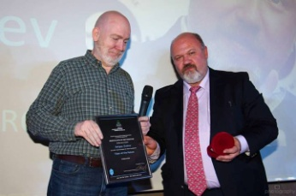
“Relations of the future” was rendered to Sudhanshu Sarronwala from World Wide Fund for Nature for his notable accomplishments.
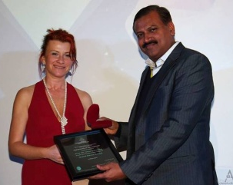
“Titan of the future” went to Sergey Zverev, Founder and President of CROS PR & Public Affairs - for a lifelong, zealous work in developing the Russian Public Relations industry.
The Grand Davos Award, the most important prize of the night, was given to Prof. Dr. Uday Salunkhe, Group Director of Welingkar Institute of Management Development & Research (now: WeSchool) and Senate Member at the University of Mumbai - for his tremendous contribution and dedication to the filed of business communication in India and the region.

