“Tolerance for the sake of the Future”:
Oleksandr Feldman Foundation Introduces a New Award as Part of WCFDavos
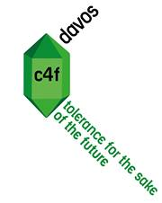
“Tolerance for the sake of the Future” Award

On March 11-12, 2014 Davos, Switzerland, hosted the 5th World Communication Forum. In the course of the Forum, Oleksandr Feldman Foundation initiated panel discussion “Values, Ethics, and Tolerance in Communications: CSR, business and community” and introduced “Tolerance for the sake of the Future” award.
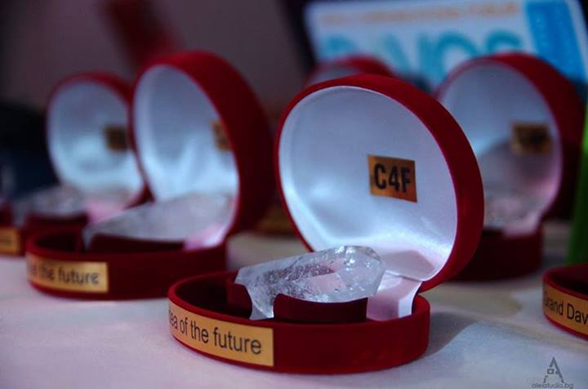
“Tolerance is among the most sensible issues in today’s world, which is best exemplified by recent Ukrainian events, where communications mistakes spilt over into mass protests. Now, it is particularly important to bring Ukraine into international focus, showing our interest in developing democratic society with equal opportunities for everyone”, said Maxim Vodka, Chairman of International Oleksandr Feldman Foundation, “Our Foundation aims at creating tolerant society in Ukraine based on mutual trust and respect.”

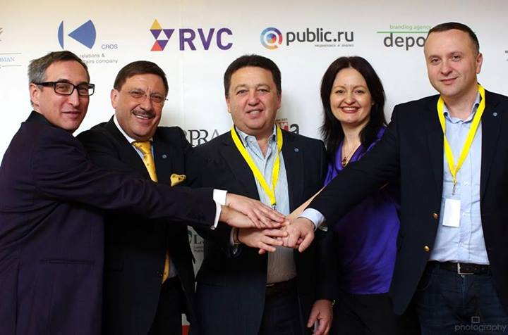
Alexander Anisimov, Maxim Behar, Oleksandr Feldman, Iryna Zlotarevych and Eduard Dolinskiy

During the panel discussion, leading international communications professionals discussed how business and communities interact and affect each other nowadays, and touched upon the needs and development forecasts of socially responsible communications. Speakers considered tolerant communications as a backbone for creating healthy and mature society, shared their experiences in and ideas for introducing the principle of tolerance into corporate culture and business activities.

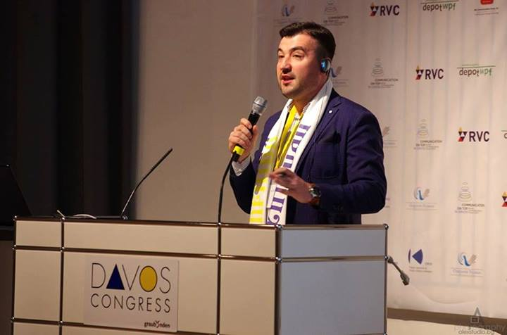
Maxim Vodka during his presentation at the 5th annual World Communication Forum in Davos

“Ability to solve problems through dialogue is a distinctive feature of the modern culture, the sign of tolerance. Charitable foundation I oversee has always supported the development of tolerance in Ukraine and worldwide, and now it’s time to bring this activity to a whole new level. With that in mind, we decided to introduce the Tolerance for the sake of the Future award. I believe this award will become another pillar for supporting tolerance and mutual respect around the world”, said Oleksandr Feldman.

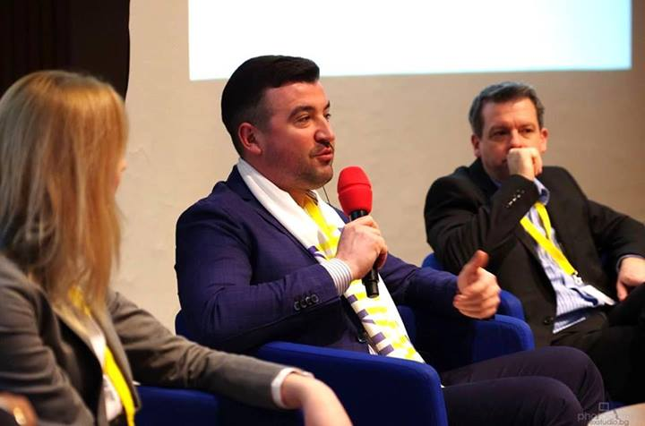
Olga Katalina, Maxim Vodka, Dr. Peter Mackelworth:'Communicating values, ethics and tolerance: CSR, business and society.'

The prize for promoting tolerance in communications and significant contribution to the future of socially responsible communications will be awarded each year during World Communication Forum Davos. Entry to the award is open to directors of NGOs, as well as CSR managers of companies practicing the philosophy of tolerance through communications, social projects, and participation in forums or exhibitions.

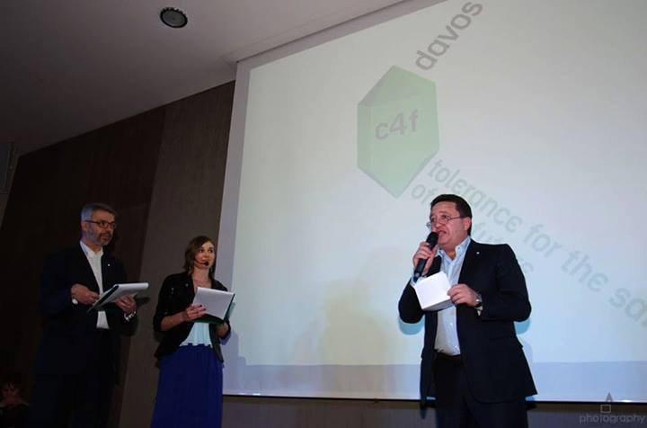
Oleksandr Feldman, announcing the 'Tolerance for the sake of the Future' category of the C4F Davos Awards

Winner of the award will be selected by Forums’ Supervisory Board. The award will be given to the nominee receiving “Worldwide Tolerance Ambassador” title based on annual results.

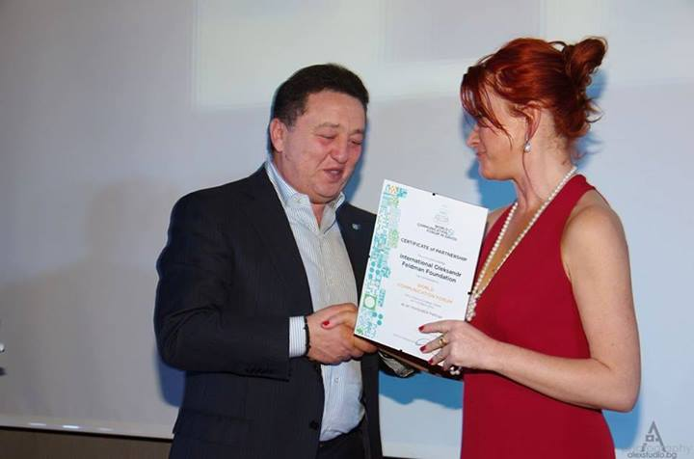
Yanina Dubeykovskaya presenting certificate of partnership to Oleksandr Feldman at the C4F Davos Awards Ceremony

International charitable fund “Oleksandr Feldman Foundation” has been committed to developing tolerant communications for 17 years. The fund’s mission is caring about the coming generation, and carrying out social programs and projects in healthcare, education, culture, and sports. Currently, organization is focused on creating a social multiplex on the grounds of Feldman Ecopark. Long-term communication with the audience is an integral part of this initiative.

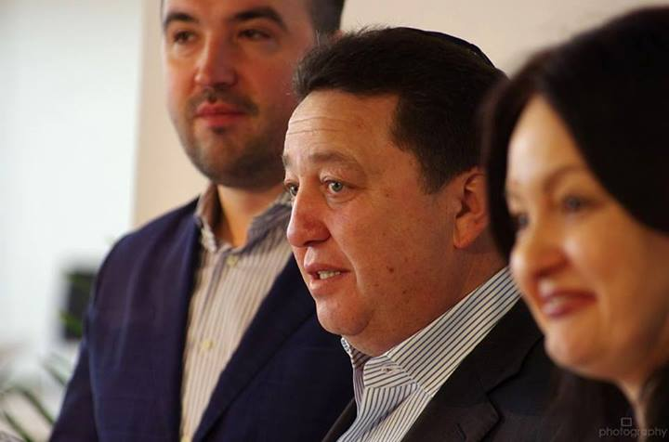
Maxim Vodka, Oleksandr Feldman and Iryna Zolotarevych at the 5th annual World Communication Forum in Davos
_________________________________________________
World Communication Forum Davos (WCFDavos) is a global platform for finding the most effective communications solutions. World Communication Forum was first held in 2010. Since that, it is the annual activity, which takes place in Davos in the same hall with World Economic Forum. The Forum unites professional community of over 3000 experts, hundreds of participants from 42 countries and 5 continents, with 29 experts from 20 countries being the members of its Coordination Committee.
FELDMAN ECOPARK - Ukraine’s first social multiplex Feldman Ecopark is a project of the International Charitable Fund “Oleksandr Feldman Foundation”, embodying 17 years of the fund’s charity expertise. This project’s major goal lies in promoting tolerant attitudes towards nature, different cultures, and religions. Today, Feldman Ecopark is focused on creating rehabilitation center for children and teenagers with mental, social, and behavioral disorders. Animal-assisted therapy takes up a special place in the treatment process as a method that allows – when accompanied with other therapeutic approaches – bringing up healthy, open and tolerant generation. With numerous educational and healthcare facilities united on its premises, Feldman Ecopark attracts both local and international visitors, offering multiple wellness and family leisure programs. On average, Ecopark is visited by 6,000 guests each day.
For additional information, please contact:Maryna Yermakova,
Tel: +380 50 355 11 59E-mail: maryna.yermakova@pleon.ua

