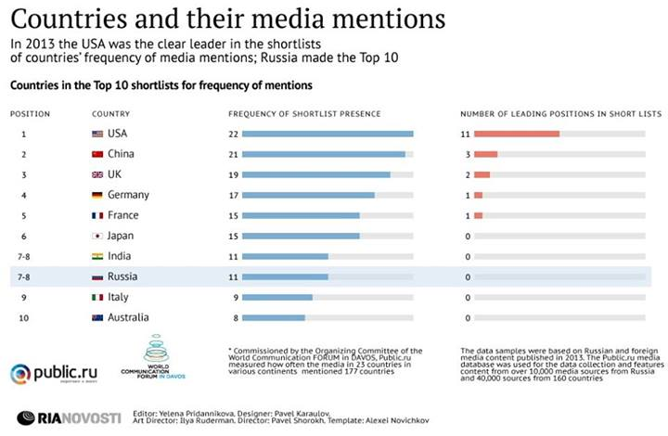
Global Media Communication Map Gets Presented in DAVOS
The international coordinating committee of the World Communication FORUM in DAVOS initiated a media research held by Public.ru, with the kind assistance of RIA Novosti, intended for measuring the frequency of mentioning of 160 countries in the G20 mass media.

As a result, a short list was created for each of 19 countries (not including the European Union):
http://marketingmreza.rs/wp-content/uploads/2014/02/infografic-RIA.jpg
The lists rank the top 10 most frequently mentioned in the media countries. The research is based on Russian and foreign mass media data for 2013. The Public.ru database uses 10 000 Russian sources and 40 000 sources from 160 countries around the world.
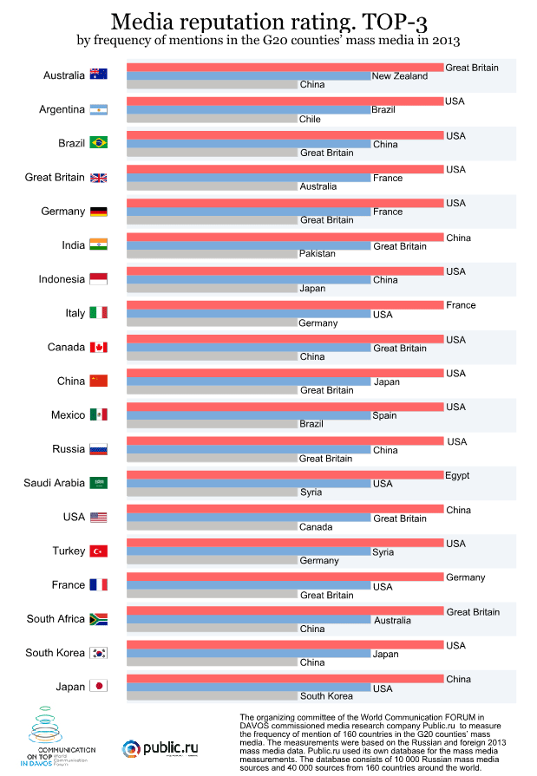
For 2013, the United States of America rates as the undisputed leader of the short lists as regards the frequency of mentioning in the different countries’ mass media. The results show 18 (out of 19) instances of its presence in the short-lists. At the same time, in more than a half of the short lists the USA is taking the lead!
The next country with top rating is China, also present in altogether 18 short lists (with 3 first nominations). Great Britain ranks third, taking the top line in 2 out of altogether 16 short lists, while Russia and India share positions 7-8:
http://marketingmreza.rs/wp-content/uploads/2014/02/g20_eng.gif

Global Media Communication Map 2013 and the complete results of the unique reserach were presented at World Communication Forum in DAVOS held on March 11-12 this year.
During the forum, each participant was able to locate their country on the global media communication map.
_______________________________________
WCFDavos bridges the gap between key markets worldwide. Initiated in 2010 by an international committee, it has gained numerous partners worldwide: IAB Europe, Holmes Report, International Communications Consultancy Organisation (ICCO), International Association of Business Communicators (EMENA), Association of PR Agencies in Switzerland (BPRA), Public Relations Consultants Association (PRCA-UK), Trans-Arabian Creative Communications (TRACCS), Mexican Association of Public Relations, Russian Public Relations Association (RPRA), Armenian Public Relations Association (APRA), Bulgarian Association of PR Agencies (BAPRA), Association of Business Communicators of India (ABCI), Brazilian Association of Communication Agencies (ABRACOM), Italian Association of Public Relations Agencies (ASSOREL), and more.

