Key PR market players “lay their cards on the table” in Davos

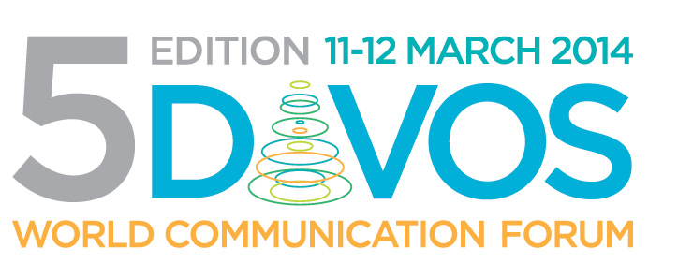
On 11-12 March, next year, during the fifth jubilee edition of World Communication Forum in Davos, owners and managers of PR consultancies, in-house corporate communications officers and board members of professional associations will “lay their cards on the table” and discuss openly current and future demands, expectations and due business relations inside the PR market.

For the first time the forum agenda includes a panel aiming to set the records straight via a “game session” revealing updates and trends in the market niche approach within the three key expert groups: public relations agencies, corporate communications, and associations that set the standards. The first round is 3 separate simultaneous discussions that focus on current structural components of the industry, each party defining demands and expectations, foreseeing the next steps in market development, and visualizing the influential role of the other parties. The second round summons to the stage elected representatives of the 3 round tables who will try to make an overview, setting the new semantic and market borders of the future communications business.

Each area will be represented by professionals from different parts of the world, among whom:
- Maxim Behar, WCFDavos Committee co-Chair, Chairman of Hill+Knowlton Strategies (Czech Republic), CEO & Board Chairman of M3 Communications (Bulgaria).
- Colin Byrne, Chief Executive Officer of Weber Shandwick for UK & Europe.
- Ankica Mamić, Owner and Managing Director of IM&C Agency (Croatia).
- Prof. Dr. Cees van Riel, co-Founder and Vice Chair of Reputation Institute (Denmark), Professor at the Rotterdam School of Management, Erasmus University.
- Solly Moeng, President of the Public Relations Institute of Southern Africa.
- Lorena Carreño Díaz, President of the Mexican Association of PR Professionals.
- Francis Ingham, Director General of the UK Public Relations Consultants Association, Executive Director of the International Communications Consultancy Organisation.
- Terri-Helen Gaynor, President of the Public Relations Institute of Australia.
Full information about the panel and speakers is available on the WCFDavos official website:
www.forumdavos.com/programme and www.forumdavos.com/speakers/2014
____________________________________________
WCFDavos is a global event that aims to bridge the gap and connect key markets worldwide. Initiated in 2010 by an international committee, it has gained the support of numerous partners worldwide: IAB Europe, Holmes Report, International Communications Consultancy Organisation (ICCO), International Association of Business Communicators in EMENA (IABC-EMENA), Public Relations Consultants Association in UK (PRCA), Association of PR Agencies in Switzerland (BPRA), Trans-Arabian Creative Communications (TRACCS), Mexican Association of Public Relations, Russian PR Association (RPRA), Armenian Public Relations Association (APRA), Bulgarian Association of PR Agencies (BAPRA), Association of Business Communicators of India (ABCI), Brazilian Association of Communication Agencies (ABRACOM), Italian Association of Public Relations Agencies (ASSOREL), and more.

Facebook: www.facebook.com/WorldCommForumDavos
Twitter: www.twitter.com/WorldCommForum
YouTube: www.youtube.com/forumdavoscom
For details on registration: www.forumdavos.com/registration

