Communications for Future (C4F) Davos Award takes place in March
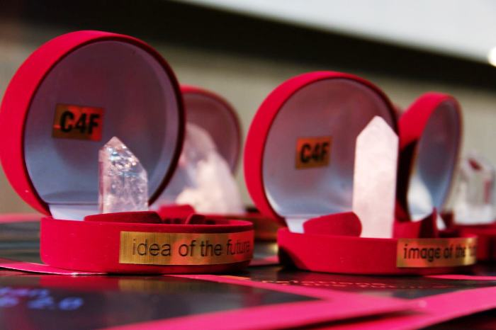
As an open global platform focused on the future development of communications, part of the annual format and tradition of World Communication Forum in Davos is to acknowledge the best creative and progressive communicators globally and honour their work achievements with a prestigious professional C4F Davos Award – an excellence award for outstanding contribution to the public relations and communications industry worldwide. Nominations’2014 have been launched.

The award is positioned in six categories:
Titan of the Future is granted to communication leaders whose personal dedication and ethical approach have played a key role in shaping up future standards within the industry. Relations of the Future recognizes the masters in reputation management, crisis communications and corporate social responsibility. Image of the Future is awarded for effective contribution to the development of visual communications. The most influential sources of information that move along with today’s digital progress will be honoured as the Media of the Future, and Idea of the future is granted to communicators with exceptional creative skills and indigenous ideas.
The utmost category is the Grand Davos Award, honouring exceptional public figures in the communications business worldwide, for their significant contribution to the industry as a whole.

Winners of C4F Davos Award 2013 in each category are:
• Gianni Catalfamo, Pleon-Italy’s Chair, Web 2.0 evangelist Pleon Europe – Titan of the Future
• Alfred Koblinger, CEO of BBDO Holding – Image of the Future
• Jason Ng, blogger, COO of geekpark.net, Twittalk.net founder – Media of the Future
• Anne Villemoes, Head of Communications for Danish Crown – Relations of the Future
• Evgeny Kuznetsov, Director Development Comms, RVC (OJSC) – Idea of the Future
• Dr. Leandro Herrero, CEO of Chalfont Project Ltd., Managing Partner of “Viral Change” (UK), author of the two bestsellers “Viral Change” and “Homo Imitans” – Grand Davos Award
Nominees are selected exclusively upon recommendation by board-representatives of partner-associations for the current year, or upon advice by members of the international committee, and the winners in each category are defined unanimously by the WCFDavos international coordinating committee. Application details and stages of the nominees' selection, as well as information about winners of the C4F Davos Award 2013, are available at the official website: www.forumdavos.com/awards
_____________________________________________
WCFDavos is a global event that aims to bridge the gap and connect key markets worldwide. Initiated in 2010 by an international committee, it has gained the support of numerous partners worldwide: IAB Europe, Holmes Report, International Communications Consultancy Organisation (ICCO), International Association of Business Communicators (IABC-EMENA), Public Relations Consultants Association in UK (PRCA), Association of PR Agencies in Switzerland (BPRA), Trans-Arabian Creative Communications (TRACCS), Mexican Association of Public Relations, Russian PR Association (RPRA), Armenian Public Relations Association (APRA), Bulgarian Association of PR Agencies (BAPRA), Association of Business Communicators of India (ABCI), Brazilian Association of Communication Agencies (ABRACOM), Italian Association of Public Relations Agencies (ASSOREL), and more.

Facebook: http://www.facebook.com/WorldCommForumDavos
Twitter: http://www.twitter.com/WorldCommForum
YouTube: http://www.youtube.com/forumdavoscom
For details on registration: http://www.forumdavos.com/registration

