5 successful years of the World Communication Forum in Davos

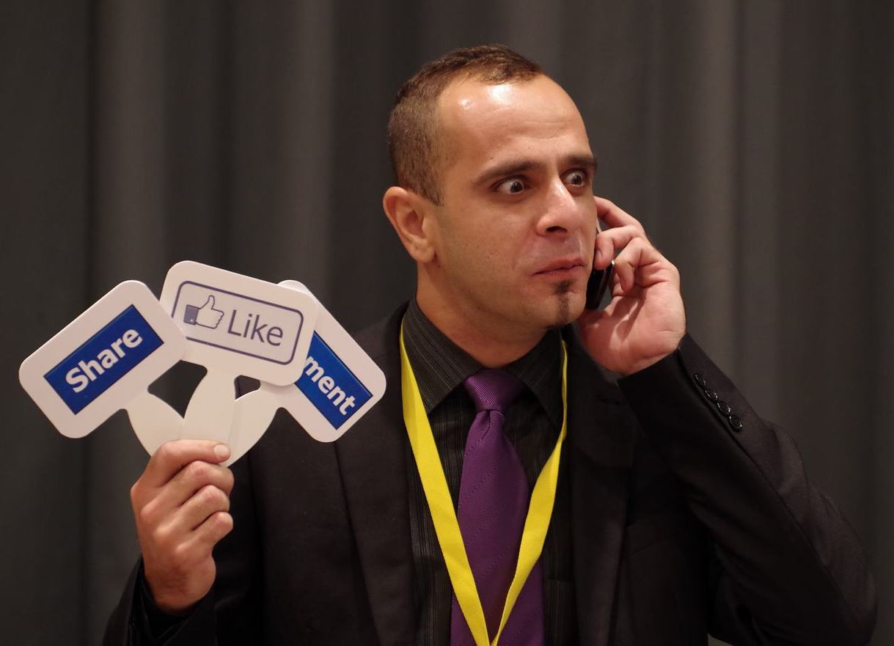
On March 11-12, next year, leading communications professionals will gather again at the annual edition of the World Communication Forum in Davos to discuss key trends in the modern public relations and communications. The jubilee edition offers interactive and gripping content: 3D vision of the Future: who creates our agenda and shapes up the future – media, politics, business, PR or science? PR is dead VS Long live All-Channel-PR, Global events’ influence on the world’s development, Global values VS local trust in political communications, International branding: engaging the global community, and more.

For the first time in its records, the forum agenda includes a panel on the industry game among three key market players – large consultancies’ leaders, board members of professional associations, and in-house communications directors will shape up future “market field rules”.
An innovative approach in communications will be presented by the co-founder and director of the Social Brain Foundation, Isaak Mao, the establisher of CNBlogs.org, who will deliver a keynote on Sharism philosophy and its impact on the new communication world.
Full information on all engaging topics listed in the WCFDavos 2014 agenda is available on the official forum website: www.forumdavos.com/program.

For the past five years, WCFDavos has successfully established a solid platform focusing on the future development of communications and uniting the industry’s main trend-makers and influencers. With its international board of communications professionals from 30 countries across 5 continents and more than 120 leading brands’ speakers sharing insight over the years, WCF has become a truly global event that captures the latest innovations in the rapidly changing public relations industry. The forum policy, defined by the coordinating committee, favours the principles of transparency, authenticity, creativity, and social engagement.
WCF Davos 2014 Committee Members: www.forumdavos.com/committee.

Yanina Dubeykovskaya, co-Chair of the Committee and Content Director of WCFDavos, shares: “Our main achievement in the past five years is the uniting of a global professional community who share the understanding that communications are a key force behind the future progress of humanity. A stronger adherence of the new communication world to the principles of sharism and transparency naturally leads to higher ethics in politics, business and society. Communications give a voice to each person, enabling us to become public opinion influencers, making us all free and more responsible for the future of the next generations.”
________________________________________
World Communication Forum in Davos is a global event initiated in 2010 by an international committee, and it has gained the support of numerous partner associations and organizations worldwide: IAB Europe, The Holmes Report, International Communications Consultancy Organisation (ICCO), International Association of Business Communicators in EMENA (IABC-EMENA), Public Relations Consultants Association in UK (PRCA), Association of PR Agencies in Switzerland (BPRA), Trans-Arabian Creative Communications (TRACCS), Mexican Association of Public Relations, Russian Public Relations Association (RPRA), Armenian Public Relations Association (APRA), Bulgarian Association of PR Agencies (BAPRA), Association of Business Communicators of India (ABCI), Brazilian Association of Communication Agencies (ABRACOM), Italian Association of Public Relations Agencies (ASSOREL), and more.

Facebook: www.facebook.com/WorldCommForumDavos
Twitter: www.twitter.com/WorldCommForum
YouTube: www.youtube.com/forumdavoscom
For details on registration: www.forumdavos.com/registration

