3 co-Chairmen lead the New Coordinating Board of WCF Davos

New Coordinating Board with three co-Chairmen upfront draws the start-line for the next edition of the World Communication Forum – a global summit of today’s communications elite!
The Board unifies top communication professionals from 20 countries across 4 continents. Its aim is to shape and promote a global community of communication professionals, standing above any political, ethnic, religious, or other differences.
The Board will also strive to secure a free expression of professional opinion, mutual professional understanding and professional cooperation, and, above all – to support the development of the communications industry worldwide, especially by fostering further increase in its social status and business value.

As a voluntary association of communications professionals, the new Coordinating Board will have three co-Chairmen, elected by the Board members:
- Andre Manning, Vice President of Corporate Communications at Royal Philips Electronics, the Netherlands;
- Maxim Behar, Chairman of Hill+Knowlton Strategies in the Czech Republic, CEO & Chairman of the Board of M3 Communications Group Inc., Bulgaria;
- Yanina Dubeykovskaya, WCF-Davos Content Director, Russia, Austria, Switzerland;

Here is what the three co-Chairpersons shared about the bright future of the summit.
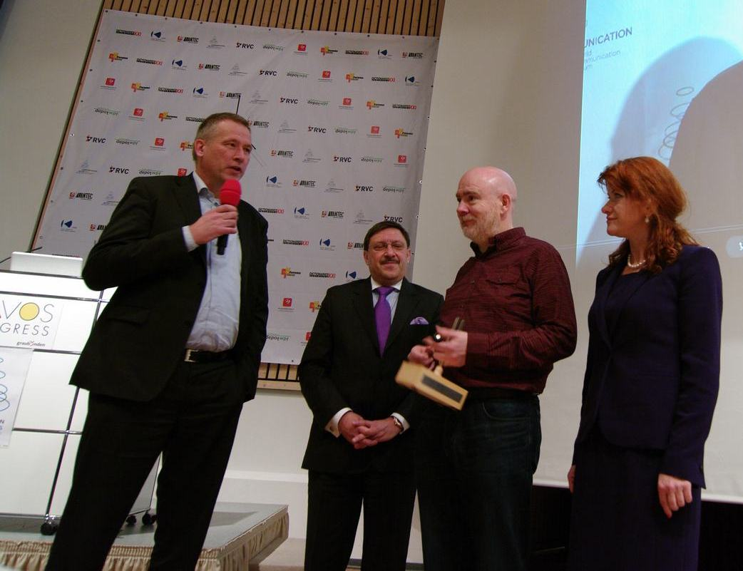
“I am excited to join the WCF Davos as a Co-Chairman of the new Board and will share my insights to grow this great organisation further”, said Andre Manning.
Maxim Behar stated: “Being with the Forum in Davos from the very first edition back in 2010, I feel huge responsibility of its development as a leading world’s public communications event. It means that all Board members must follow the events in our business on a daily basis in a way that next year we will have a completely new and a much more useful program for our participants. It is a great responsibility as one of the Chairmen, to lead this process and to raise the branding and positioning of the Forum. It is a great place of exchanging ideas and in our business it is obvious that ideas drive the whole world.”
Yanina Dubeykovskaya added: „We need a new committee with fresh energy and ideas for developing the Forum in a really global direction, and for organizing regional events. A week ago we had one in Moscow and we are starting the preparations for WCF-Davos/Prague and WCF-Davos/Mumbai.”

The Board members shall have the exclusive right to give suggestions on the annual Forum’s agenda, to recommend communications experts as speakers, to make nominations for the prestigious C4F-Davos Awards and vote for the winners. All of them are highly-recognized well-established communications professionals from around the world:
- Alexander Anisimov, Executive Director of WCF-Davos and Top Communications GmbH, Austria, Russia;
- Alfred Koblinger, CEO of BBDO Holding, Austria;
- Casey Lau, Hong Kong tech start-up pioneer, co-founder of StartupsHK, Community Developer for SoftLayer's Catalyst Startup Program, Hong Kong, China;
- Daniel Hӧltgen, Director of Communications at the Council of Europe, France;
- Dymitr Romanowski, Co-founder and CEO of The Story digital branding agency, Poland;
- Francis Ingham, Director General of the UK Public Relations Consultants Association (PRCA);
- Gary Grates, Principal at WCG Worldwide, ex-President and Global Managing Director of EDELMAN Change and Employee Engagement, USA;
- Gianni Catalfamo, European Digital Director, Ketchum Pleon, Italy;
- James Gillies, Head of the Communications Group at CERN, Switzerland;
- Juan Carlos Belloso, Director at Future Places: Place Competitiveness and Development, Spain;
- Lorena Carreño Díaz, President of the Mexican Association of Public Relations Professionals (PRORP);
- Natalia Belenko, Founder of Top Communication GmbH, Russia;
- Nurul Ashiqin Shamsuri, CEO of Lubri Oil Corporation SB, Malaysia;
- Paul Holmes, Founder and CEO of The Holmes Report and the SABRE Awards, UK;
- Philippe Borremans, Chief Social Media Officer Van Marcke Group, Belgium;
- Rui Martins, Corporate Communication and Public Affairs Director at Dianova, Portugal;
- Sergey Zverev, Founder and President of CROS PR&PA, Russia;
- Stephen Davies, Senior Consultant at 33 Digital, UK;
- Stuart Bruce, Digital Corporate Communications, Online PR trainer & consultant, UK;
- Sultan Al-Bazie, CEO of Attariq Communications Chair of IPRA Gulf Chapter, Saudi Arabia;
- Svetlana Kananykhina, CEO of Event Life Communication, WCF-Davos Event Director, Russia;
- Valery Levchenko, Deputy Editor in Chief at RIA Novosti, Russia;
- Yannis Freris, Director of Corporate Communication & Sustainable Development at GEFYRA S.A., Greece;
- Yogesh Joshi, President of the Association of Business Communicators of India (ABCI).

You can find out more at: http://www.forumdavos.com/committee

The World Communication Forum has had 4 editions in Davos, Switzerland. Its main idea is to unite trend-makers and influencers from the communications elite and to provide a platform for discussion focused on the future development of communications, their role in business, society, and politics. Since 2010 the Forum has registered a hundreds of international partners and associations, speakers and participants from 40 countries across 5 continents. The crystal of the Forum is C4F (Communication for Future) Davos Awards for top professionals in different aspects of the communications industry.

Contacts:
Kalina Toncheva,
PR Manager at Top Communication Gmbh
mobile: +359 895 660 628,
е-mail: press@forumdavos.com
website: www.forumdavos.com

Official profiles:
Facebook: http://www.facebook.com/WorldCommForumDavos
Twitter: http://www.twitter.com/WorldCommForum
YouTube: http://www.youtube.com/forumdavoscom

