Foreseeing the future of global communications
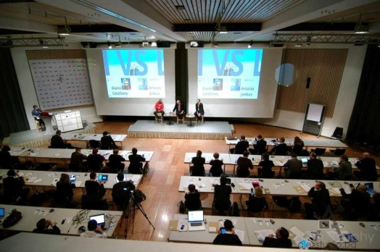
Top communications professionals and thought leaders from Europe, USA, Russia, India, China, Brazil & more gathered at the World Communication Forum in Davos, Switerland.
“The Forum aims to bring together the new elite – communications experts who are capable of predicting the next steps in the development of the industry and creating new business value”, said Yanina Dubeykovskaya, Co-founder and Content Director at WCF. “The fourth edition of the World Communication Forum in Davos focuses on the clash between global and local communications, new mechanisms of trust and engagement, creativity as a key expertise, the growing influence of the visual language, the status of reality in social media, and the viral change.”
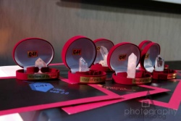
The C4F (Communication for Future) Davos Awards played a key part in foreseeing the future. Their motto is “See the future, and the future will see you!”. This special award ceremony is annually held with the intention to express recognition to outstanding communicators with creative approach, revolutionary visions on the future and who have had an impact on the development of the communications industry. Here are this year’s awardees in the following six categories:
- Image of the future – Alfred Koblinger, CEO of BBDO Holding (Austria)
- Media of the future – Jason Ng, Blogger, Twitter activist, COO of geekpark.net, Founder of Twittalk.net, Start-Upper (China)
- Idea of the future – Evgeny Kuznetsov, Director Development & Communications Department at Russian Venture Company
- Relations of the future – Anne Villemoes, Director of Corporate Communications at Danish Crown company (Denmark)
- Titan of the future – Gianni Catalfamo, Founder at cc:catalfamo (Italy)
- Grand Davos Awards – Dr. Leandro Herrero, CEO The Chalfont Project Ltd. & Managing Partner Viral Change Global LLP, (UK)
Additionally, there was be a sub-event during the forum this February – the first Creative Class Global Meeting. Its main idea is to unite innovative creators with bright ideas, who share similar values and are somehow connected by the social networks. It provoked them to think whether a “new manifest” is possible and how they could cooperate in a world-changing way.
In general by now the World Communication Forum has been supported by a great number of international partner associations and organizations from about 40 countries around the globe: IAB Europe, The Holmes Report (USA), International Communications Consultancy Organisation (ICCO), Public Relations Consultants Association (PRCA) in UK, Association of PR Agencies in Switzerland (BPRA), Trans-Arabian Creative Communications (TRACCS), PRORP – The Mexican Association of Public Relations, Russian Public Relations Association (RPRA), Armenian Public Relations Association (APRA), Association of Business Communicators of India (ABCI), Brazilian Association of Communication Agencies - ABRACOM and more.
The Forum was broadcasted live and was actively presented in the social networks during the event itself, as well as throughout the whole year. A unique mark of this edition was the offline opportunity for the participants to Like, Comment & Share.

Interview with the Grand Davos Awardee from World Communication Forum 2013:
https://www.facebook.com/notes/communication-on-top-davos/viral-change-will-your-company-survive-the-epidemic/444594695609375

Contacts:
Kalina Toncheva,
PR Manager at Top Communication Gmbh
mobile: +359 895 660 628,
е-mail: press@forumdavos.com
website: www.forumdavos.com

Official profiles:
Facebook: http://www.facebook.com/WorldCommForumDavos
Twitter: http://www.twitter.com/WorldCommForum
YouTube: http://www.youtube.com/forumdavoscom

