“See the future, and the future will see you!”

That’s the motto of the C4F (Communication for Future) Davos Awards – Annual Excellence Awards for Communication Professionals. The official ceremony and Gala dinner will take place on the 7th of February as a part of the World Communication Forum, held in Davos for the 4th time.
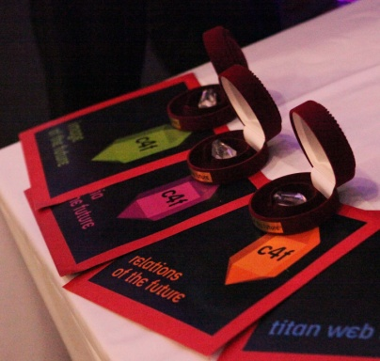
Among the nominees for 2013 are: Dr. Leandro Herrero, CEO The Chalfont Project Ltd. & Managing Partner Viral Change Global LLP, (UK) Gianni Catalfamo, Founder at cc:catalfamo (Italy), Evgeny Kuznetsov, Director Development & Communications Department at Russian Venture Company, Alfred Koblinger, CEO of BBDO Holding, (Austria), Anne Villemoes, Director of Corporate Communications at Danish Crown company (Denmark), Andre Manning, Global Head Corporate Communications at Philips, Global HQ (Netherlands), Jason Ng, Blogger, Twitter activist, COO of geekpark.net, Founder of Twittalk.net, Start-Upper, (China), Yogesh Joshi, President of the Association of Business Communicators of India (ABCI), Nurul Ashiqin Shamsuri, CEO of Lubri Oil Corporation Malaysia SB, and Stuart Bruce, digital corporate communications and online PR blogger, trainer and consultant (UK).

C4F Davos Awards include 6 categories, two of which will be presented for the first time:
- Titan of the future is given to people, who are creative in every aspect, available 24/7 and committed to the high business and ethical standards of true global leaders. Some call them multi-taskers, but we consider them to be the re-born Leonardo da Vinci-s.
- Image of the future’s nominees are professionals who create stunning images and develop the visual communications of the future, just as Steve Jobs did.
- Media of the future is mobile, interactive and social. The award in this category is granted to those who foresee the next step in media development.
- Relations of the future category recognizes the masters in Reputation Management, Crisis Communications and Corporate Social Responsibility, who help building up competitive advantages.
- Idea of the future’s nominees are representatives of the creative economy, where communicating what does not yet exist has become a key factor in the development of adequate communications for innovations.
- Grand Davos Award is to be granted to key figures and thought leaders for their whole contribution to the communications industry.

C4F Davos Awards are the first of their kind to express recognition of outstanding communicators with creative approach and innovative visions on the future of communications. They are given to individuals with huge influence on the improvement of communications and truly effective contribution in fostering new trends in the development of the communications industry worldwide. All C4F Award holders are visionaries, challenging the status quo with their perception about future and leaving their unique impact on the world.

Winners of World Communication Forum 2012:
http://www.forumdavos.com/awards/2012

Contacts:
Kalina Toncheva,
PR Manager at Top Communication Gmbh
mobile: +359 895 660 628,
е-mail: press@forumdavos.com
website: www.forumdavos.com

Official profiles:
Facebook: http://www.facebook.com/WorldCommForumDavos
Twitter: http://www.twitter.com/WorldCommForum
YouTube: http://www.youtube.com/forumdavoscom

