World Communication Forum gathers top experts from 30 countries

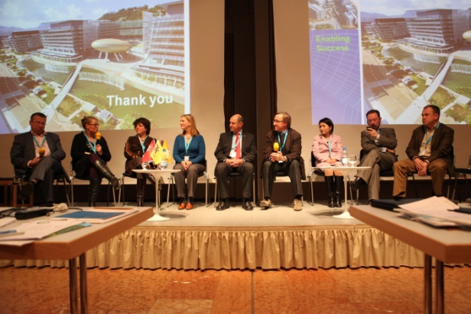
On 7-8 February, at the World Communication Forum in Davos, high-level communications professionals will seek for answers to important issues, such as: “Is there a chance for the global, chain-like PR agencies?”, “What is today's world-change-driver: Human Creativity or Technology?”, "The reputation of the banking sector: Managing the unmanageable?". For the first time, except for the involving presentations, great debates and revolutionary round-table panels, there will be industrial discussions.
Among the “seekers” at the forum will be remarkable experts and speakers like Paul Holmes – founder and CEO of the Holmes Report and SABRE awards, Stuart Bruce – top-rated social media expert and influential blogger, founder of Stuart Bruce Associates (SBPR), UK, Dr. Alfred Koblinger – CEO of BBDO, Austria, Andre Manning, Global Head Corporate Communications at Philips, Global HQ, Netherlands, Anne Villemoes, Director of Corporate Communications at Danish Crown company, Denmark, Maxim Behar – Chairman Hill+Knowlton Strategies, Czech Republic, CEO & Chairman of the Board M3 Communications Group Inc., Bulgaria, Nurul Ashiqin Shamsuri – CEO of Lubri Oil Corporation (M) SB, Malaysia, James Ng – Co-Founder at GeekPark.Net, China, and James Gillies – Head of Communications at CERN, Swizterland.
Additionally, the agenda will include the C4F (Communication for Future) Davos Awards. It is an annual excellence awards ceremony for communication professionals, with the intention to express recognition of outstanding communicators with creative approach and revolutionary visions on the future.
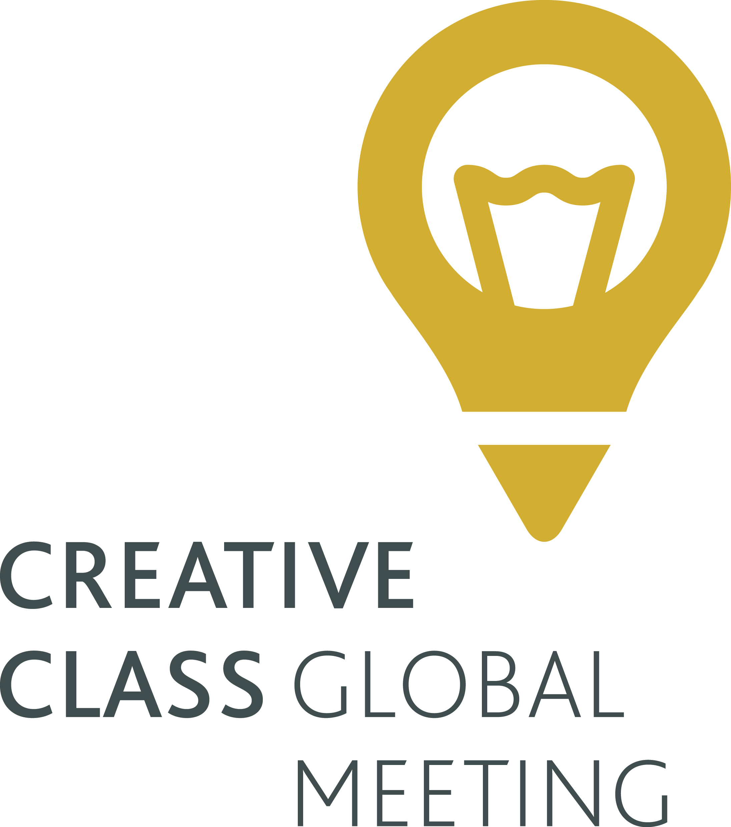
At this 4th edition there will be a sub-event during the forum – the first Creative Class Global Meeting. Its main idea is to unite brave creators, innovative and bright minds, who share similar values and are somehow connected by the social networks. It will provoke them to think whether a “new manifest” is possible and how they could cooperate in a world-changing way.
The World Communication Forum was created in 2009 by the international coordination committee. Its fundamental idea is to summon the new communications elite to an annual global conference for an open discussion of the contemporary communications professional agenda and also for sharing best practices, strategies and creative ideas. In 3 years only the forum has registered a huge number of international partner associations and organizations from 40 countries across 5 continents: IAB Europe, The Holmes Report, International Communications Consultancy Organisation (ICCO), Public Relations Consultants Association (PRCA), Association of PR Agencies in Switzerland (BPRA), Trans-Arabian Creative Communications (TRACCS), PRORP – The Mexican Association of Public Relations, Russian Public Relations Association (RPRA), Armenian Public Relations Association (APRA), Association of Business Communicators of India (ABCI), Brazilian Association of Communication Agencies - ABRACOM and more.

Contacts:
Kalina Toncheva,
PR Manager at Top Communication Gmbh
mobile: +359 895 660 628,
е-mail: press@forumdavos.com
website: www.forumdavos.com

Official profiles:
Facebook: http://www.facebook.com/WorldCommForumDavos
Twitter: http://www.twitter.com/WorldCommForum
YouTube: http://www.youtube.com/forumdavoscom

