World Communication Forum promotes young professionals worldwide

For its 4th edition on 7-8 February, 2013, the World Communication Forum in Davos (Switzerland) has exceptional discounts in order to promote young professionals.
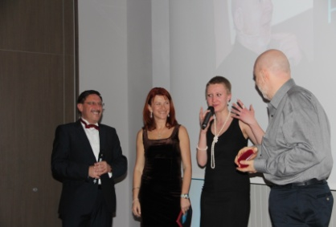
The World Communication Forum opens up 10 places for MA and PHD students in PR, Marketing and Communications at a very special price: 800 euro for the two days, including including C4F Davos Awards Gala, lunches and transfer. It is truly an amazing opportunity for both freshman and experts into the communications industry to get together and share ideas, knowledge and experience. Being inspired and passionate about it, Yanina Dubeykovskaya, the Content Director of the Forum, shared: “We believe that young professionals will stay the base of the next generation, who will be the first digital natives. The digital-selves of this new anthropology type will be in the core of communicating at all. This will be a generation, which will have a wider vision of the future and will set new trends into the global communications.”
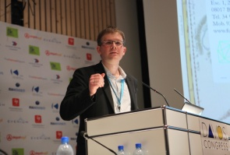
The World Communication Forum was created in 2009 by the international coordination committee. Its fundamental idea is to summon the new communications elite to an annual global conference for an open discussion of the contemporary communications professional agenda and also for sharing best practices, strategies and creative ideas. In 3 years only the forum has registered a huge number of international partner associations and organizations from 35 countries across 5 continents: IAB Europe, The Holmes Report, The London School of Public Relations and Branding (LSPR), Trans-Arabian Creative Communications (TRACCS), PRORP – The Mexican Association of Public Relations, Russian Public Relations Association (RPRA), Armenian Public Relations Association (APRA), Association of Business Communicators of India (ABCI) and more.

The program of World Communication Forum in 2013 will offer many provokative presentations, a lot of discussions and hot debates on diverse topics, such as “Global vs. Local Communications”, “Regulations & limits of freedom on the Internet and Copyright”, “Today's world-change-driver: Human Creativity or Technology?”, “Text vs. Image”, “Social PR vs. Traditional PR”, and more. You can find records of all the debates, discussions and interviews held at the event so far on its YouTube Channel – www.youtube.com/user/forumdavoscom.

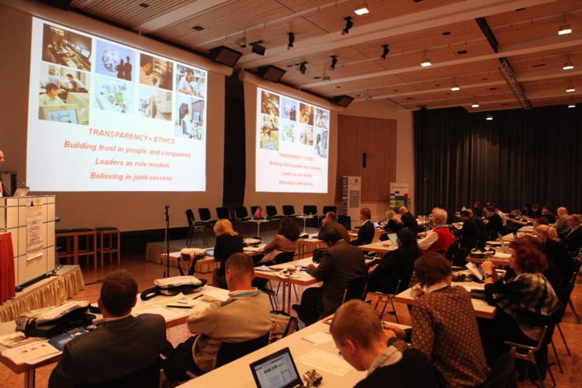
If you are a MA and PHD student in PR, Marketing and Communications, please fill out our registration form at http://www.forumdavos.com/registration and send it to forum@forumdavos.com. We would be glad to make you part of the new communications elite, formed at World Communication Forum in Davos!

Contacts:
Kalina Toncheva
PR Manager
at Top Communication Gmbh
е-mail: press@forumdavos.com

Official WCF Profiles:
Facebook: www.facebook.com/WorldCommForumDavos
Twitter: www.twitter.com/WorldCommForum
YouTube: www.youtube.com/forumdavoscom

